

**ΔΙΕΘΝΕΣ ΧΟΡΩΔΙΑΚΟ ΦΕΣΤΙΒΑΛ ΠΡΕΒΕΖΑΣ**

INTERNATIONAL CHORAL FESTIVAL OF PREVEZA

**2nd INTERNATIONAL CHORAL CONDUCTING COMPETITION OF PREVEZA 2025**

8th-9th July 2025

On the occasion of its 43rd anniversary, the Preveza Choral Festival organized the 2nd biennial International Competition of Choral Conductors (2025). In a wonderful atmosphere and ambience, the selected conductors will showcase their skills of working with two top choirs **‘’Armonia’’ Children’s Choir of Preveza (Greece)** and **KGBL Chamber Choir (Slovenia).** The competition will take place at the Cultural **Centre of Holy Metropolis of Preveza** and be judged by a jury of eight internationally renowned conductors and composers.

|  |
| --- |
| **APPLICATION** |

**1. Participation**

**The competition is open for choral conductors born after 6th July 1990.**

**Competition is organized in two categories:**

Each conductor can apply for one or both Categories.

**Category - A, MIXED CHOIR CONDUCTORS (three rounds):**

* Rehearsal with KGBL Chamber Choir - Renaissance Music Romantic (1st Round),
* Rehearsal with KGBL Chamber Choir - Romantic and early 20th Century Music (2nd Round),
* Public concert with KGBL Chamber Choir (3rd Round-Finale).

**Category - B, CHILDREN'S CHOIR CONDUCTORS (one round):**

* Rehearsal with ‘Armonia’’ Children’s Choir of Preveza

**Official language of the competition is English.**

The competition is open to a public audience (except for the afternoon rehearsal with the choir for the final concert). Competitors **cannot** attend the round in the hall if they are competing.

**2. Application materials**

**Deadline** for application: **April 25th, 2025**.

**Required documents:**

By email **prevezachoralfestival@gmail.com**

* CV (biography)
* An interesting picture in high resolution

By post or **WeTransfer** to **prevezachoralfestival@gmail.com**

* A DVD of a concert and a rehearsal - the choir conducted by the competitor.

The conductor must be clearly seen, from far away.

The recording should be at least 15 minutes long. Recording Day may not be prior to July 6th, 2020.

* Recommendation letter of a conducting professor or a reputable choral expert or the national choral organization of the competitor’s country.

|  |
| --- |
| **JURY AND MARKS** |

**1. Members of the jury and work of the jury**

The jury will consist of 8 esteemed members, choral music experts from Greece and from abroad.

Members of the jury:

**Yu-Chung** **Johnny Ku** (Taiwan)

**Eduardo Garcia Novelli** (Argentina, USA)

**Yana Deliradeva** (Bulgaria)

**Paweł** **Łukaszewski** (Poland)

**Josu Elberdin** (Spain)

**Ambrož Čopi** (Slovenia)

**Roni Sugiarto** (Indonesia)

**Angeliki Ploka** (Greece, Netherlands)

Every member of the jury will evaluate the conductor with a numerical estimate of up to 100 points in each Round. Considered when evaluating: **the manual technique of the conductor, concept of the rehearsal with the choir, interpretation, contact with the choir.**

Each conductor will have a chance to speak with the jury members after the competition about their presentations and get suggestions for their work in the future.

**Category A, Mixed Choir Conductors Competition**

**The points from the 1st Round and 2nd Round shall be added together. The top three candidates will participate in the 3rd Round - Finals** of the Conducting Competition of Preveza.

**The performance in the finals will consist of the evaluation of the jury and the choir.**

**Namely in the ratio of the jury 80%, the choir 20%.**

**2. The declaration of the results for Category A, Mixed Choir Conductors Competition**

The names of the participants for the 3rd round will be announced **two hours after the end of the 2nd round**. The results of the competition will be publicly announced **after the Opening Ceremony of the International Choral Festival of Preveza** on Thursday, July 10th,2025. The decisions of the jury are final. Appeals are not possible.

**3. The declaration of the results for Category B, Children’s Choir Conductors Competition**

The results of the competition will be publicly announced **after the Opening Ceremony of the International Choral Festival of Preveza** on Thursday, July 10th,2025. The decisions of the jury are final. Appeals are not possible.

|  |
| --- |
| **INTERNATIONAL CHORAL CONDUCTORS COMPETITION** |

**Category A, MIXED CHOIR CONDUCTORS (three rounds):**

**TUESDAY, July 8th, 2025**

9:00 a.m. Arrival, registration.

9:30 a.m. Draw of order and compositions for 1st and 2nd Round.

**10:00 a.m.** **1st Round Competition** (KGBL Chamber Choir).

**6:00 p.m. 2nd Round Competition** (KGBL Chamber Choir).

9:30 p.m. Announcement of competitors for finals.

Draw of order and compositions for finals.

**WEDNESDAY, July 9th, 2025**

3:00 p.m.  **3rd Round - Finals / part 1** - Rehearsal with KGBL Chamber Choir.

**8:00 p.m.  3rd Round - Finals / part 2 – CONCERT** with KGBL Chamber Choir**.**

**Category B, CHILDREN'S CHOIR CONDUCTORS (one round)**

**THURSDAY, July 10th, 2025**

9:00 a.m. Arrival, registration.

9:30 a.m. Draw of order and compositions

**10:00 p.m.** (One) **Round Competition** (’Armonia’’ Children's Choir of Preveza)

|  |
| --- |
| **THURSDAY, July 10th, 2025, 9:00 p.m.**  **OPENING CEREMONY OF THE INTERNATIONAL CHORAL FESTIVAL OF PREVEZA & PRIZE GIVING CEREMONY FOR CHORAL CONDUCTORS COMPETITION** |

*\*The organizer holds the right to make changes in the schedule according to the number of participants in each category. The other participants will be informed of any changes in time.*

|  |
| --- |
| **AWARDS AND MEDALS, DIPLOMAS** |

**DIPLOMAS:**

All the participants will receive a diploma of participation.

|  |
| --- |
| **AWARDS:** |

**CATEGORY A, MIXED CHOIR CONDUCTORS**

**1st AWARD 1.000,00** €, the gold medal and diploma

**TAIPEI PHILHARMONIC CHAMBER CHOIR AWARD**

**Invitation to conduct a concert in 2026/2027**

**2nd AWARD 500,00** €,the silver medal and diploma

**3rd AWARD 300,00** €,the bronze medal and diploma

**CATEGORY - B / CHILDREN’S CHOIR CONDUCTORS**

**1st AWARD 500,00** €, the festival medal and diploma

**2nd AWARD 300,00** €,the festival medal and diploma

**3rd AWARD 250,00** €,the festival medal and diploma

*The jury evaluates the competitors with points from 0 to 80. The assembly evaluates from 0 to 20 points. The points from the 1st and 2nd round are not added up in the final. The sum of the points of the jury and the choir must be at least 90 points for the 1st prize, 85 points for the 2nd prize and 80 points for the 3rd prize.*

|  |
| --- |
| **SPECIAL AWARDS:** |

The jury can award:

* **Special Award**for the **most inspiring conductor**,
* **Special Award for well-thought-out pedagogic approach** with the choir (1st and 2nd Round),
* **Special Award**to the**most perspective young conductor**(born after July 2000)of the competition,
* **Special Award for** the best performance of **contemporary composition** (Finals),
* **Special Award for** the best performance of **renaissance composition** (Finals),
* **Special Award for**the best performance of **romantic composition** (Finals),
* **Special Award to** the best **Greek conductor.**

*After the Jury’s proposal, additional prizes may be awarded.*

**THE AWARD OF THE CHOIR**

for **the most charismatic choral conductor**at the Final concert of the 2ndInternational Choral Conductors Competition of Preveza 2025, chosen by the **KGBL Chamber Choir** (practical prize).

**TAIPEI PHILHARMONIC CHAMBER CHOIR (Taiwan)**

**Taipei Philharmonic Chamber Choir (TPCC)** is a 30-voice chamber choir from Taiwan. It was established in 1993, out of the 150-voice Taipei Philharmonic Chorus (founded in1972). TPCC has an impressive history of performing internationally. They have been to all continents of the world, performed in major performance venues in more than 40 cities. The choir has participated in various International Choral Festivals, such as International Chamber Choir Festival in Latvia in 1995, the 4th World Symposium on Choral Music in Sydney, Australia in 1996, Festival Vancouver in 2000 & 2009, Asia-South-Pacific Symposium on Choral Music in Singapore in 2001, the 6th World Symposium on Choral Music in Minneapolis/St. Paul, U.S.A. in 2002, Oregon Bach Festival in Eugene, U.S.A. in 2006, Zempléni Fesztivál and Cantemus Festival in Hungary in 2007 & 2014, ACDA National Convention in Chicago in 2011, Polyfollia Festival in Saint Lo, France in 2013, Melbourne Festival in Australia and the Next Wave Festival in New York, U.S.A. in 2017, among others. In 2016, TPCC was invited to perform in the “Holy Mass and Canonization of Blessed Mother Theresa of Calcutta” in Vatican. In 2023, TPCC was invited to be one of the 10 international choirs featured in the World Symposium on Choral Music in Türkiye.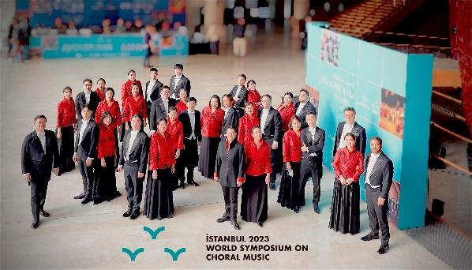

The current Music Director of TPCC is Dr. Yu-Chung Johnny Ku, with Professor Dirk DuHei, the founder of this choir, as the Artistic Director. In addition to working with Dr. Ku, TPCC also invites internationally renowned conductors to Taiwan as guest-conductors frequently. The choir has worked with Helmuth Rilling, Maria Guinand, Gábor Hollerung, Jonathan Velasco, Theodora Pavlovitch, Fred Sjöberg, André Thomas, Jānis Liepiņš, Alexander Solovyev, Ambrož Čopi, among others. The repertoire of TPCC ranges from renaissance to contemporary, from European classics to Asian countries, and the compositions with Taiwanese and Chinese heritage. On top of these choral treasures, TPCC has also been commissioning and premiering more than 200 new works from Taiwanese composers and composers around the world since 1993. TPCC’s albums have constantly been nominated for “Golden Melody Award” and have won “Best Album” award and “Best Singing Performance” awards several times.

**Dr. Yu-Chung Johnny Ku** is the Music Director of Taipei Philharmonic Chorus and Taipei Philharmonic Chamber Choir. He is also the Music Director of Taipei International Choral Festival and Competition, the conductor of Dream Lotus Chorus, an executive board member of Taiwan Choral Association, an assistant professor in the National Taiwan University of Arts and the Fu-Jen Catholic University, a member of the World Choral Council, a member of the Asia-Pacific working committee in the International Federation for Choral Music, co-founder of the World Choral Championship, and one of the founding directors of the Asian Choral Association. Ku is an active conductor working with not only choirs, but also orchestras, operas, musical theaters, and pop concerts. He has given concerts, masterclasses, workshops, and lectures in more than 20 countries around the world, including Australia, Austria, Bulgaria, Cambodia, Canada, China, Czech, Hong-Kong, Hungary, Indonesia, Italy, Japan, Korea, Macao, Malaysia, Philippines, Poland, Russia, Singapore, Taiwan, Türkiye, the USA, among others. Also, he and the Taipei Philharmonic Chamber Choir have been invited to perform in several prestigious international music festivals, including the ACDA national convention, the Next Wave Festival of BAM, Melbourne Festival, and the 2023 World Symposium on Choral Music in Türkiye, to name a few.

Dr. Ku has served as the Chorus Master for more than 50 operas and choral-symphonic productions of National Symphony Orchestra, National Taiwan Symphony Orchestra, and National Kaohsiung Center for the Arts, working alongside with Frieder Bernius, Charles Dutoit, Günther Herbig, Jahja Ling, Jun Märkl, Helmuth Rilling, among others. In addition, he has been an adjudicator in international competitions, including the World Choir Games, World Choral Festival, Bali International Choral Competition, Singapore International Choral Competition, Penabur International Choir Festival, Busan Choral Festival and Competition, and several others. Dr. Yu-Chung Johnny Ku received his D.M.A. from the College Conservatory of Music at the University of Cincinnati, and holds a master degree from Temple University.

|  |
| --- |
| **COMPETITION PROGRAM / CATEGORY - A, CHOIR CONDUCTORS** |

**1st ROUND**

TUESDAY, July 8th, 2025, at 10:00 a.m.

Rehearsal with **KGBL Chamber Choir** (conductor **Ambrož Čopi**)

**Renaissance music** / Rehearsal with **KGBL Chamber Choir** (conductor **Ambrož Čopi**)

Max. 8 participants

Each participant conducts the obligatory composition (no rehearsing) and rehearses for 20 minutes of compulsory composition and one composition drawn by lot.

List of compositions:

**Obligatory piece** (conducted directly): 

William Byrd (1543–1624): AVE VERUM CORPUS *(*Pope Innocent VI)

**Compulsory piece** (for rehearsal):

Giovanni Gabrieli (1557–1612): JUBILATE DEO (Psalm 99:2-3)

**Drawn by lot** (for rehearsal):

Jacob Handl - Gallus (1550–1591): DUO SERAPHIM OM 3/1 (Matins Responsory)

MEDIA VITA OM 1/65

**2nd ROUND**

TUESDAY, July 8th, 2025, at 6:00 p.m.

Rehearsal with **KGBL Chamber Choir** (conductor **Ambrož Čopi**), **Lara Oprešnik**, piano

**Romantic** / Rehearsal with **KGBL Chamber Choir** (conductor **Ambrož Čopi**)

Max. 8 participants

Each participant conducts the obligatory composition (no rehearsing) and rehearses for 20 minutes of compulsory composition and one composition drawn by lot.

List of compositions:

**Obligatory piece** (conducted directly):

Gabriel Faure (1845–1924): CANTIQUE DE JEAN RACIN, op. 11 (Jean Racine)

**Compulsory piece** (for rehearsal):

Giuseppe Verdi (1813–1901): PATER NOSTER (Antonio Beccari da Ferrara)

**Drawn by lot** (for rehearsal):

Hugo Wolf (1860–1903): IM STILLEN FRIEDHOF (Ludwig Pfau)

Johannes Brahms (1833–1897): EIN DEUTCHES REQUIEM, op. 45

I. Selig sind, die da Leid tragen

IV. Wie lieblich sind deine Wohnungen

**3rd ROUND - FINALS**

WEDNESDAY, July 9th, 2025, at 3:00 p.m.

**PART 1 -** Rehearsal with **KGBL Chamber Choir** (conductor **Ambrož Čopi**)

**(without jury and public)**

3 participants

Each participant has 70 minutes time for rehearsal (no jury) to prepare two obligatory compositions and two of six other compositions drawn by lot.

**List of compositions:**

**Obligatory compositions:**

Renaissance and Romantic music:

Giovanni Gabrieli (1557–1612): JUBILATE DEO (Psalm 99:2-3)

Giuseppe Verdi (1813–1901): PATER NOSTER (Antonio Beccari da Ferrara)

**Two compositions drawn by lot.**

21st century music:

Tine Bec (1993): LAUDATE DOMINUM OMNES GENTES (Psalm 116: 1-2)

Federica Lo Pinto (1997): SOLEIL (text by: various authors)

Andrej Makor (1987): CANTATE DOMINO OMNIS TERRA (Psalm 95 (96): 1-3, 1a)

Klara Mlakar (1999): CHERUBIC HYMN (Text in [Old] Church Slavonic)

Ambrož Čopi (1973): JUBILATE DEO UNIVERSA TERRA (Psalm 66(65): 1b, 2a, 16)

Tadeja Vulc (1978) SINE SOLE NIHIL SUM (texts from Sundials)

Scores by Slovenian composers are published by **Astrum Music Publications** ([info@astrum.si](mailto:info@astrum.si)) except Sine sole nihil sum.

WEDNESDAY, July 9th, 2025, at 8:30 p.m.

**PART 2 - Public concert with KGBL Chamber Choir**

Each participant performs the obligatory composition and three compositions, rehearsed in the afternoon with KGBL Chamber Choir.

**DEMONSTRATIVE CHOIR / CATEGORY A**

**KGBL CHAMBER CHOIR, Ljubljana (Slovenia)**

**Conservatorium of Music and Balet Ljubljana Chamber Choir** (KGBL Chamber choir) led by **Ambrož Čopi** consists of about 40 singers who are willing to improve their vocal technique, sing a more demanding range of choral music and reach higher performing standards. The choir regularly collaborates with vocal educators Edita Garčević Koželj and Tatjana Vasle.

The KGBL Chamber Choir embraces a wide range of music genres and styles, from the Renaissance to modern music. In the past years the choir had commissioned many prominent composers, such as Lojze Lebič, Tadeja Vulc, Damijan Močnik, Črt Sojar-Voglar, Peter Šavli, Andrej Makor, Tine Bec, Matej Kastelic, Klara Mlakar, Jan Triler and Federica Lo Pinto to create new compositions, which it successfully promotes at concerts and competitions in Slovenia and abroad. It is one of the most important promoters of young Slovenian composers’ generation. In the past KGBL Chamber Choir was awarded with second and third place at the International choral competition Tallinn (Estonia, 2015); won the Grand prix in Moscow (Russia, 2016); it achieved first place at the National choral competition ''Naša pesem'' (Our song), Maribor (Slovenia, 2016); second place at the International choral competition ''Gallus'' Maribor (Slovenia, 2017); first place in category Polifonia and second place in category Folklore at the International choral competition in Tolosa (Spain, 2017); first place in Cork International choral competition (Ireland, 2019); gold award at World Choir Festival (Hong Kong) in 2021 and two gold awards, category winner and grand prix winner "Choir of the World" award in 2023. 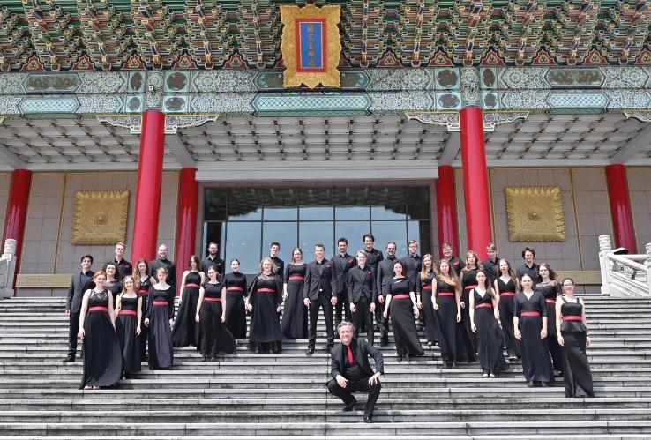

The choir successfully performed various concert cycles in Slovenia and abroad: Stockholm (Sweden, 2016); Borja, Ordizia, Getxo, Doneztebe (Spain, 2017); International Festivals in Basel (Switzerland, 2018); Taipei International Choral Festival (Taiwan, 2018) and Beijing (China, 2018). MITO festival (Italy, 2021), Voices of Spirit, Graz (Austria, 2022), Florilege de Vocal de Tours (France, 2022), Budapest choral festival (Hungary, 2022), Festival Laureates in Provence (France, 2023), Taipei International Choral Festival (Taiwan, 2023), Il Polifonico Guido d'Arezzo (Italy, 2023), Ipoh and Kuala Lumpur (Malaysia, 2024) and Singapore (Singapore, 2024).

The Choir has released three CDs: Credo, Timeless and Ubi caritas et amor.

Info: <https://www.choirkgbl.eu/>

YouTube: <https://www.youtube.com/@kgblchamberchoir380/videos>

|  |
| --- |
| **COMPETITION PROGRAM / CATEGORY - B, CHILDREN’S CHOIR CONDUCTORS** |

**(ONE) ROUND**

THURSDAY, July 10th, 2025, at 10:00 a.m.

Rehearsal with **‘Armonia’’ Children's Choir of Preveza** (conductor **Aneliya Hristova Stefanova**)

Max. 5 participants

Each participant conducts the obligatory composition (no rehearsing) and rehearses for 20 minutes the compulsory composition and one of three movements of Petite mass drawn by lot.

List of compositions:

**Obligatory piece** (conducted directly): 

Konstantinos Matis (1979), arr.: TO MARGOUTHI (traditional Thrace, Greece)

**Compulsory piece** (for rehearsal):

Tasos Pappas (1926-1970), arr.: TESSERA PIMENIKA ASMATA (traditional Greek songs)

**Drawn by lot** (for rehearsal):

John Leavitt (1956): PETITE MASS

I. Kyrie Eleison

II. Gloria

III. Agnus Dei

**DEMONSTRATIVE CHOIR / CATEGORY B**

**ARMONIA CHILDREN'S CHOIR, Preveza (Greece)**

The **Children’s Choir “Armonia” of Preveza** was founded in 1983 by the conductor Andronikos Kourouklis and it is a section of Choral Society “Armonia” of Preveza. Other conductors of the choir who greatly contributed to its brilliant course and success were Stavros Solomos and Valentin Stefanov. Since 1994, the choir has been directed by **Aneliya Stefanova**. During its existence the choir has been awarded 3 first, 2 second and 2 third prizes in International Choral Competitions (Bulgaria, Greece, Italy, Switzerland, Hungary, Poland) and it has also been awarded twice as the best Greek Children’s choir in the International Choral Festival of Athens. It regularly performs in festivals both in Greece (Ioannina, Agrinio, Katerini, Kefalonia, Athens, Patras, Thessaloniki, etc., Olympic Games ATHENS 2004) and abroad (International Choral Festival "Aram Khatsaturian" in Haskovo, Bulgaria 2003, International Festival in Rome. Italy 2008, Easter Festival of Moscow, Russia 2017) while it has participated in premieres of works and cooperated with renowned orchestras and soloists. Its last major success was in October 2023, when it participated in the 18th International "Gaude Cantem" Competition in Bielsko-Biala, Poland, where it won the gold medal and 1st place in its category as well as 4 special awards. Last summer, the choir chosen to participate in Eurochestries International Festival which took place in La Rochelle (Charente-Maritime), France from 29th of July to 12 of August 2024, where it collaborated with youth orchestras from all over the world and realized 10 concerts with rich Greek repertory.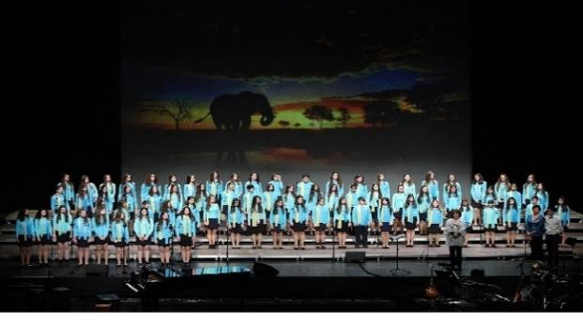

|  |
| --- |
| **FINANCIAL OBLIGATIONS** |

### 1. Application fee

**100 EUR (non-refundable)**, to be paid upon application to the account:

NATIONAL BANK OF GREECE

Choral society “Armonia” of Preveza

Account number: 448/480188-16

Swift Code – Bic: ETHNGRAA

IBAN: GR 7201 1044 8000 0044 8480 18816

After receiving the transfer, an invoice will be sent to the candidate for the paid registration fee.

### 2. Accommodation and food costs

Participants will have to cover the cost of accommodation and food by themselves. Organizers can help them with suggestions and information, but they will have to book directly.

### 3. Transportation costs

Transportation costs are covered by participants themselves.

### 4. Photos, audio and video rights

All audio and video rights belong to the organizer of the competition. The partcipants receive no compensation for their performance; however, they receive a video and photos of their performance.

|  |
| --- |
| **LEGAL MATTERS** |

1. The organizer is not responsible for any possible accidents, losses, theft and such, during the competition and the choirs’ stay in Preveza.
2. Official language of the competition is English.
3. With the application, the conductors confirm that they accept the conditions of the competition.
4. The organization committee holds the right to change the conditions and terms of the competition upon unexpected circumstances. The organization committee must inform the participating conductor of such changes in writing.